Lab assignment -6.1

Name:Bommideni pranitha

Idno:2403A51351

Batch number:14

Task Description #1 (Classes – Employee Management)

* Task: Use AI to create an Employee class with attributes (name, id, salary) and a method to calculate yearly salary.
* Instructions:
  + Prompt AI to generate the Employee class.
  + Analyze the generated code for correctness and structure.
  + Ask AI to add a method to give a bonus and recalculate salary.

Prompt:

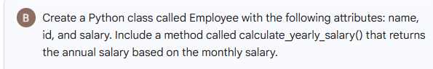

Code: in static

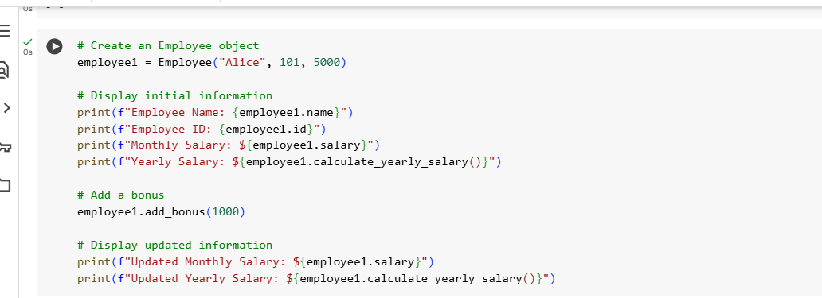

Expected Output #1:

* A class with constructor, display_details(), and calculate_bonus() methods.

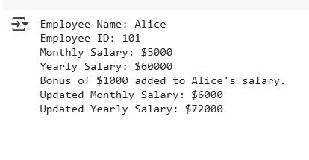

Task Description #2 (Loops – Automorphic Numbers in a Range)

* Task: Prompt AI to generate a function that displays all Automorphic numbers between 1 and 1000 using a for loop.
* Instructions:
  + Get AI-generated code to list Automorphic numbers using a for loop.
  + Analyze the correctness and efficiency of the generated logic.

Ask AI to regenerate using a while loop and compare both implementations

Prompt:

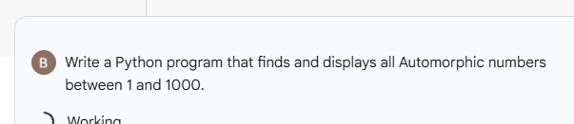

Code:

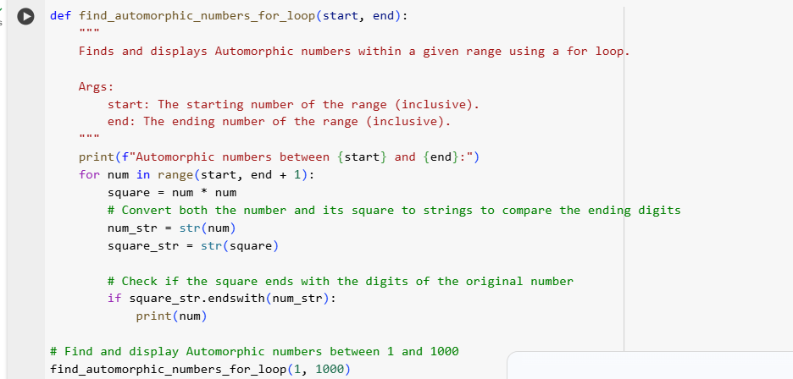

Output:

* Correct implementation that lists Automorphic numbers using both loop types, with explanation.

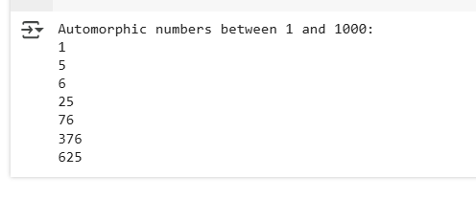

Task Description #3 (Conditional Statements – Online Shopping Feedback Classification)

* Task: Ask AI to write nested if-elif-else conditions to classify online shopping feedback as Positive, Neutral, or Negative based on a numerical rating (1–5).
* Instructions:
  + Generate initial code using nested if-elif-else.
  + Analyze correctness and readability.
  + Ask AI to rewrite using dictionary-based or match-case structure.

Prompt:



Code

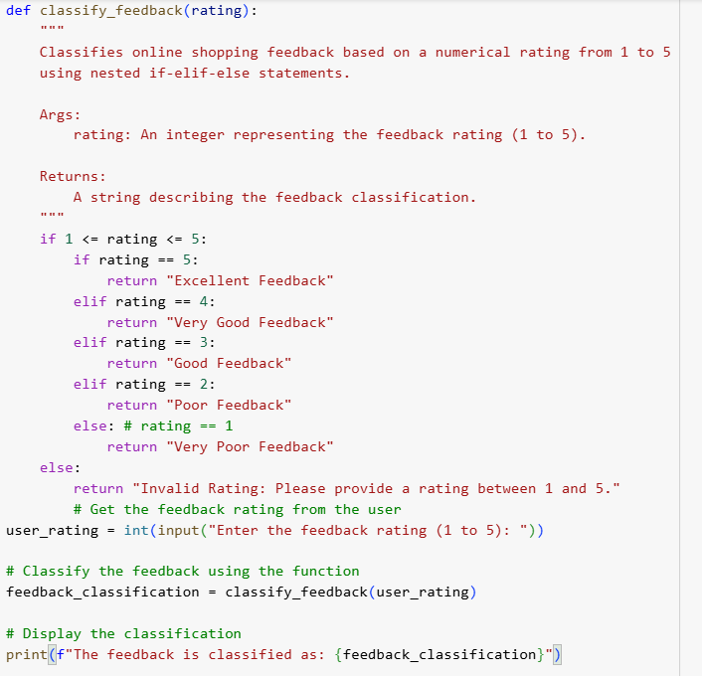

Output:

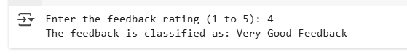

Task Description #5 (Classes – Library System)

* Task: Use AI to build a Library class with methods to add_book(), issue_book(), and display_books().
* Instructions:
  + Generate Library class code using AI.
  + Analyze if methods handle edge cases (e.g., issuing unavailable books).
  + Ask AI to add comments and documentation.

Prompt:

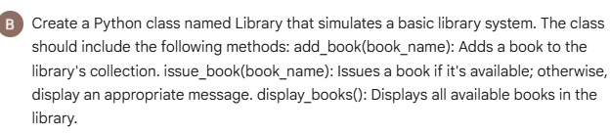

Code

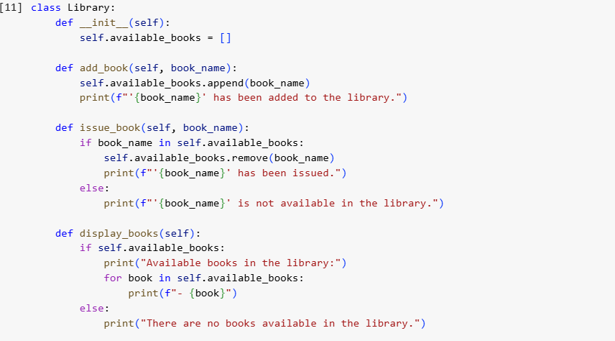

Output:

For this code only the library function is created and asked only to create the library it is the best example for the zero shot problem

Task Description #4 (Loops – Prime Numbers in a Range)

* Task: Generate a function using AI that displays all prime numbers within a user-specified range (e.g., 1 to 500).
* Instructions:
  + Get AI-generated code to list all primes using a for loop.
  + Analyze the correctness and efficiency of the prime-checking logic.
  + Ask AI to regenerate an optimized version (e.g., using the square root method).

Prompt  
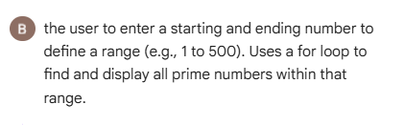

Code:

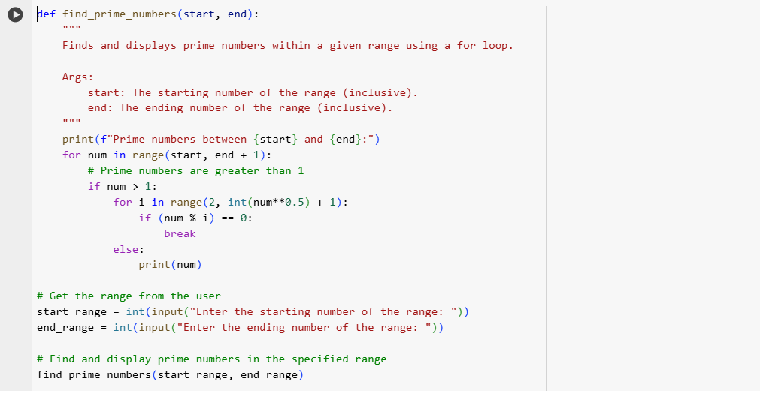

Output

